IndyOfComo — 7/9/2018 10:42 AM
Have you had a response about script writing yet? What can you tell me about what you are looking for?

lootnils — 7/11/2018 7:12 AM
Hey, sorry for my late reply, no we have not recieved any response until now. What we are looking for is, we are giving out points per hour watchtime, we want to limit this points to a maximum of 8 hours or the equivalent in points, even if we stream longer, no user shall get more than those 8 hours watchtime/points

IndyOfComo — 7/11/2018 12:45 PM
oh, giving out points is an inherant part of the bot, not part of the scripting. What I could do is write a script which keeps track of how long someone has been watching, and when user gets over 8hrs watched the script actually uses the remove points command to undo what your currency settings will do. Do you actually have the currency settings set up to only give based on the hour? I'm not sure that means it gives points based on per-hour watched, just that it only gives out every hour. I could be there just for the hour tick and still get the points.

lootnils — 7/11/2018 1:14 PM
Okay so if someone is watchin 3 hours in the morning and again 6 hours in the evening he will only get the points for the total 8 hours and the 1 hour left will be removed by the remove command, correct? We dont give points on full hours but on minutes

IndyOfComo — 7/11/2018 3:32 PM
I think I can do this without too much problem. I am a professional programmer but Python is new to me, I'm still learning on my own scripts. I'd estimate I can do this within 20 hrs. How does $30 USD sound to you?

lootnils — 7/11/2018 3:43 PM
30$ for the script sounds about right, is it okay if i get back to you tomorrow when i am back in the office? I am going to write down the exact details of what the script should do, if okay

IndyOfComo — 7/11/2018 3:47 PM
That's totally fine. I'd like a screenshot of your currency settings. Also I'll have other questions I'll have for you to get a good solid user requirement document together. Is Shiv your handle on Twitch? I'd like to follow you, check out your stream.

lootnils — 7/11/2018 3:50 PM
the channel is https://www.twitch.tv/lootchestde my twitch handle is itsshiver on Twitch
Sounds great, i think in the future we might have more work like this
i will get back to you tomorrow

lootnils — 7/13/2018 3:12 AM
So, we finally gathered all the Information: We are using Streamlabs Chatbot 1.0.2.48 We are using Streamlabs Currency which is locally saved Every 10 Minutes a Viewer gets 1 Point We want to Limit the Points a Viewer can get to 80 a Day (8 hours by 10 points per Hour) now matter how long we stream, so if we stream 16 Hours a day, only 8 Hours should be given out in Points (80) I will give you a screenshot of the settings also. If you give me your Paypal Adress i can arrange the Payment pretty quickly. Thank you very much
Settings:
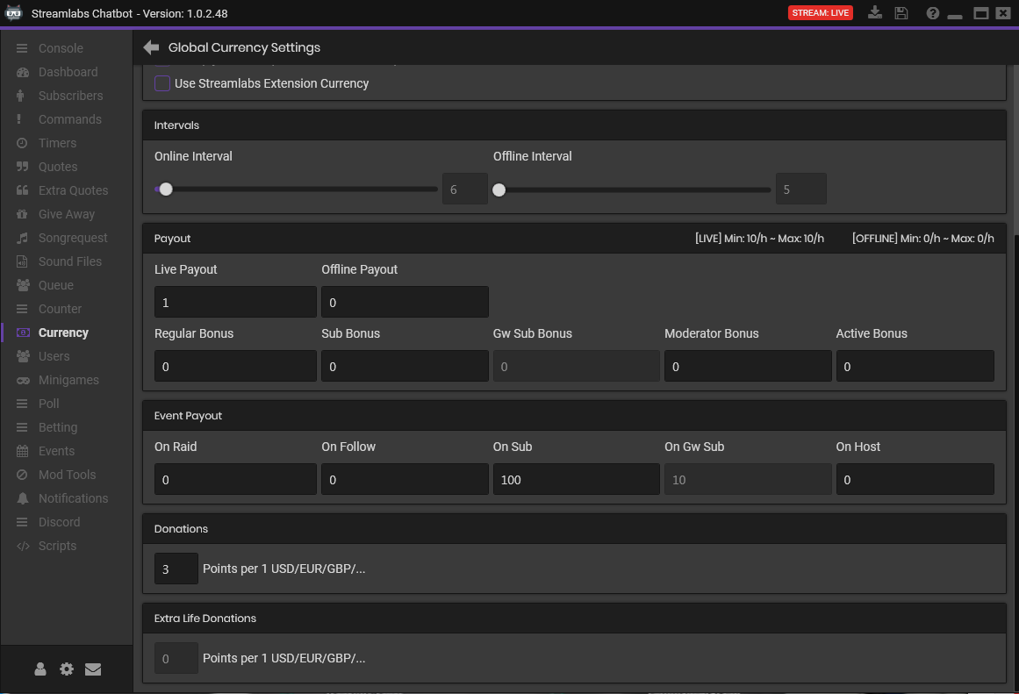

IndyOfComo — 7/15/2018 10:02 AM
Thank you for that information! I have one more question for you: When do you want the day to turn over? Do you want it to be based on local time? Thus if you are live from 2:00pm until 5:00am the next day and a viewer watches you the entire stream, that viewer would get credit for watching you from 2-10pm, then max out and get no currency from 10pm-12am, and then get currency for 12-5am. Also, with this approach a viewer who watches the channel from 4pm-5am would get 13 hours of currency. Or do you want it to be based on discrete streams? Using this in the above example the viewer would get currency through 10pm but not start earning currency until you went offline at 5am and came back online. Both of the examples above assumed the viewer was starting the stream without having watched any earlier that day.
I have been unemployed for a few months and I have a face-to-face interview this Monday. I will be traveling out today and returning on Monday; I'll start on the project Tuesday. xxxxxxxxx@gmail.com is my Paypal account. Thank you.

lootnils — 7/15/2018 1:14 PM
Hey, thank you for your reply, i think the easiest way is to reset it at midnight? if that makes sense, so everytime a new day starts, the counter will reset, so that the viewer is then again able to get the points

IndyOfComo — 7/15/2018 1:26 PM
Yes, that would probably also be the easiest to code, and the easiest for viewers to understand. (Because eventually someone will ask.)

lootnils — 7/19/2018 3:48 AM
Hello, any news on the script?

IndyOfComo — 7/19/2018 9:07 AM
I'm sorry I've been really busy with my job hunt. I have finally caught up with submitting resumes though so now it's my #1 project. I expect to be done by Monday.

lootnils — 7/19/2018 9:30 AM
Alright, perfect, thank you for the heads up

IndyOfComo — 7/21/2018 1:30 PM
Hello. Do you have bot accounts blacklisted in bot from earning currency?

IndyOfComo — 7/22/2018 1:31 PM
Version 1 is going in to final testing.

IndyOfComo — 7/22/2018 9:44 PM
Hello! Below I will include the zip file containing the script you commissioned me to write for you. I included two sets of the UI_Configuration file and the script itself, one with the text visible to you in English and another in German. (Thanks to @Wikwak3 for translating for me.) All you need to do is remove the ".ENG" or ".GER" at the end of the file names of the ones you wish to use. Do not remove the language extension off of both of them. The script will create files daily and retain them for possible historical or debugging needs. You will want to go in and delete older files regularly. However often you choose to do this, I would suggest retaining a history going back 2-3 weeks. As I make improvements I will send you updated zip files. Please report any unexpected behaviors to me. A current limitation: The viewer history will not be saved if you disable the script in SL Chatbot's Scripts tab. It is only saved upon closing SL Chatbot and when the day changes (23:59 --> 00:00). If you have further requests for this script or any other, please don't hesitate to contact me again.
Thank you!

6.70 KB

lootnils — 7/23/2018 3:33 AM
Thank you very much! We will implement your script this week! I am looking forward to working with you again

lootnils — 7/27/2018 7:46 AM
Hello, i have a small Problem, somehow the script is not showing in the scripts tab, i have tried it with different scripts and they all work, i am running Streamlabs Chatbot 1.0.2.49 with python 2.7.13
I also removed the .ger extensions, but something seems to be wrong, any ideas?
In the Script Errors Tab i get the following Info:
FileName: .\Services\Scripts\CurrencyLimiter\CurrencyLimiter_SteamlabsSystem.py
LineNr: 22
Message: Non-ASCII character '\xe4' in file. \Servoces\Scripts\CurrencyLimiter_Streamlabs_System.py on line 22, but no encoding declared

IndyOfComo — 7/27/2018 11:22 AM
ah, I know what it is!
it's the German!
Wä(<--- that right there)hrung Begrenzer
Will the English set work?

lootnils — 7/27/2018 11:31 AM
i will try it in english later

IndyOfComo — 7/27/2018 11:39 AM
line 22 isn't part of the code, not really. It is the lines which appear on the scripts tab. So there's no coding around that to let it read the German letters.

lootnils — 7/27/2018 12:01 PM
i will try the english version now, one second
Yes, the english Version is showing up

IndyOfComo — 7/27/2018 12:04 PM
ok. Darn. Tried to give you something nice and extra with the German version, but that's not going to work out.

lootnils — 7/27/2018 12:06 PM
the english version is going to work
just enabled the script
this showed up in the chat:
: xentaria: 6; lootchestde: 6; ancaron: 6; derdmk: 6; n8fux1337: 6; janina19: 6; odin4u82: 6; neg8tor: 6; decafsmurf: 6; oshovah1: 6; lootnils: 6; bittersweet1987: 6; katherol: 6; kptdende: 6; 0x2f7c37: 6; maciflecki: 6; reisfarm: 6; electricallongboard: 6; berserkertv88: 6; fabenus: 6; keeperxy: 6; elve2023: 6; ollnom: 6; trivialtv: 6; hbcobra: 6; felsbroeckchen: 6; tommyxx3: 6; brutalisx1337: 6; turbiii: 6; wuermling: 6; nederbash: 6; blaulichter: 6;
Do you know what that means?

IndyOfComo — 7/27/2018 12:07 PM
in chat?

lootnils — 7/27/2018 12:07 PM
yes

IndyOfComo — 7/27/2018 12:07 PM
oh jeez, you'll want to disable that real quick. Let me send you a quick fix

lootnils — 7/27/2018 12:08 PM
This got posted for a lot of users

IndyOfComo — 7/27/2018 12:10 PM
QUICK FIX 9 KB
that was part of my own testing / debugging, it wasn't supposed to be active anymore.
the message to chat I mean
^^that file has it turned off

lootnils — 7/27/2018 12:15 PM
yes, i will test it now one sec

IndyOfComo — 7/27/2018 12:15 PM
I will watch

lootnils — 7/27/2018 12:19 PM
its active again now

IndyOfComo — 7/27/2018 12:19 PM
You should see nothing if it works properly.

lootnils — 7/27/2018 12:20 PM
yes it seems to work now, at least no messages have been posted to the chat
i am not quite sure how to check if it works properly, but i am going to write down the points of some users tomorrow, to see if they change as they should
thank you very much for the quick help and fix

IndyOfComo — 7/27/2018 12:25 PM
I can build that into it. That'll be an upgrade I send to you.

